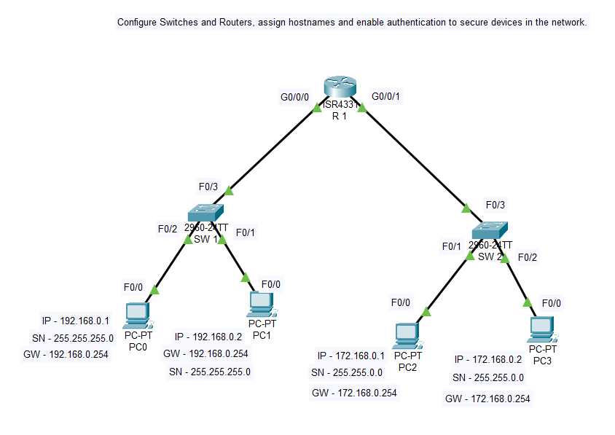
1. Configure Switches and Routers, assign hostnames and enable authentication to secure devices in the network.

SW1
#en
#config t
#hostname SW1
#enable secret kasc
#line console 0
#password kasc1
#login
#exit
#end
#interface f0/1-24
#no shutdown
#exit
#end
#wr
SW2
#en
#config t
#hostname SW2
#enable secret kasc
#line console 0
#password kasc1
#login
#exit
#end
#interface f0/1-24
#no shutdown
#exit
#end
#wr
R1
#en
#config t
#hostname R1
#enable secret kasc
#line console 0
#password kasc1
#login
#exit
#end
#interface g0/0/0
#ip addess 192.168.0.254 255.255.255.0
#no shutdown
#ip address 172.168.0.254 255.255.255.0
#no shutdown
#exit
#end
#wr
OUTPUT:

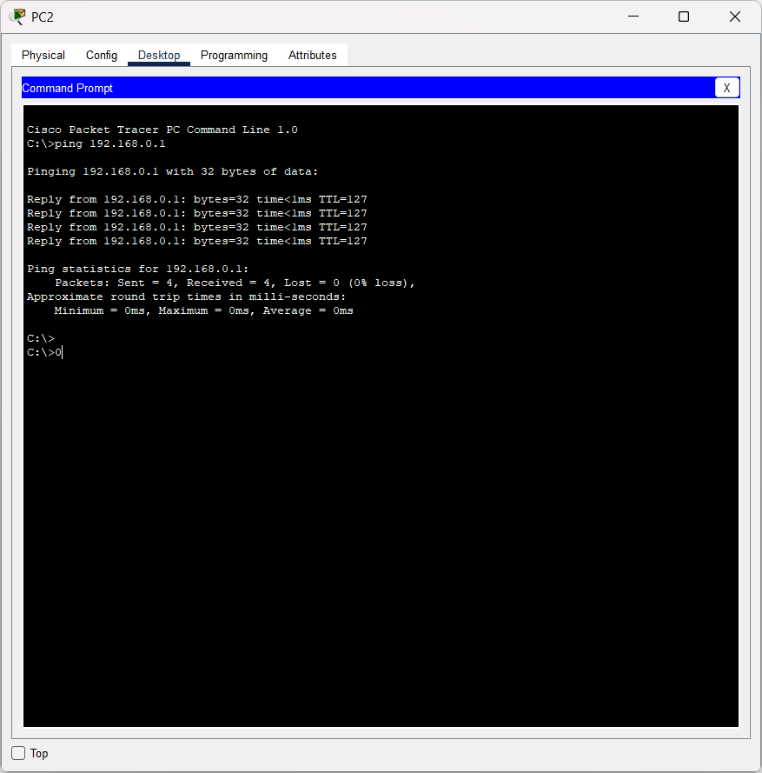

2. Setup VLAN interfaces on Switches and Routers, assign IP addresses and simulate LAN connectivity.

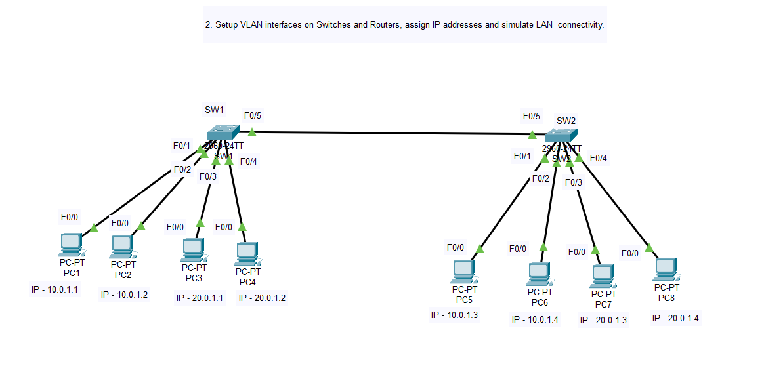

SW 1
Switch>en
Switch#config t
Switch(config)#vlan 10
Switch(config-vlan)#name VLAN10
Switch(config-vlan)#exit
Switch(config)#vlan 20
Switch(config-vlan)#name VLAN20
Switch(config-vlan)#exit
Switch(config)#exit
Switch#

Switch#wr
Building configuration...
SW 2
Switch>en
Switch#config t
Switch(config)#vlan 10
Switch(config-vlan)#name VLAN10
Switch(config-vlan)#exit
Switch(config)#vlan 20
Switch(config-vlan)#name VLAN20
Switch(config-vlan)#exit
Switch(config)#exit
Switch#
Switch#wr
Building configuration...
-------------------------------------------------------------------------------------------------------------
SW1
Switch#config t
Switch(config)#interface f0/1
Switch(config-if)#switchport mode access
Switch(config-if)#switchport access vlan 10
Switch(config-if)#exit
Switch(config)#interface f0/2
Switch(config-if)#switchport mode access
Switch(config-if)#switchport access vlan 10
Switch(config-if)#exit
Switch(config)#interface f0/3
Switch(config-if)#switchport mode access
Switch(config-if)#switchport access vlan 20
Switch(config-if)#exit
Switch(config)#interface f0/4
Switch(config-if)#switchport mode access
Switch(config-if)#switchport access vlan 20
Switch(config-if)#exit
Switch(config)#
Switch(config)#exit
Switch#
Switch#wr
Building configuration...
SW 2
Switch#config t
Switch(config)#interface f0/1
Switch(config-if)#switchport mode access
Switch(config-if)#switchport access vlan 10
Switch(config-if)#exit
Switch(config)#interface f0/2
Switch(config-if)#switchport mode access
Switch(config-if)#switchport access vlan 10
Switch(config-if)#exit
Switch(config)#interface f0/3
Switch(config-if)#switchport mode access
Switch(config-if)#switchport access vlan 20
Switch(config-if)#exit
Switch(config)#interface f0/4
Switch(config-if)#switchport mode access
Switch(config-if)#switchport access vlan 20
Switch(config-if)#exit
Switch(config)#
Switch(config)#exit
Switch#
Switch#wr
Building configuration...
SW 1
config t
Switch(config)#interface f0/5
Switch(config-if)#switchport mode trunk
SW2
config t
Switch(config)#interface f0/5
Switch(config-if)#switchport mode trunk
OUTPUT
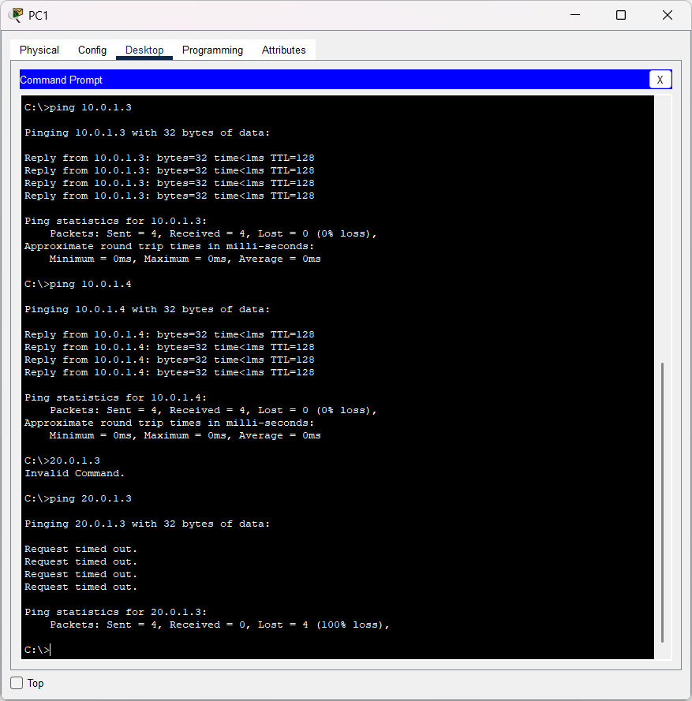

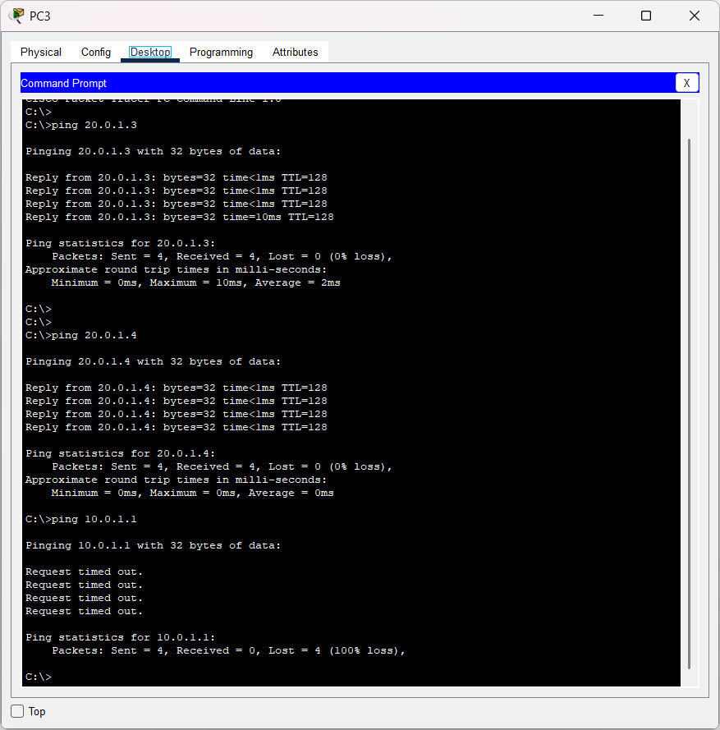

3. Configure and verify Static Routes between multiple routers.
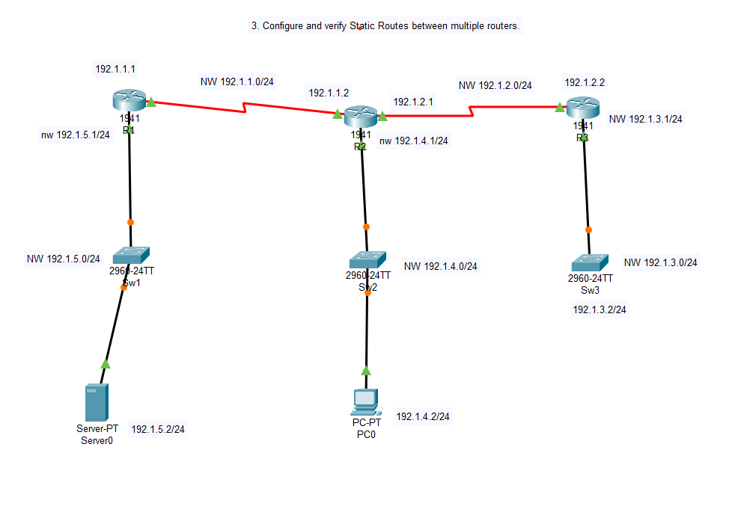
ROUTER 1
Router>enable
Router#configure terminal
Router(config)#hostname R1

R1(config)#interface gigabitEthernet 0/0
R1(config-if)#ip address 192.1.5.1 255.255.255.0
R1(config-if)#no shutdown
R1(config-if)#exit

R1(config)#interface serial 0/1/0
R1(config-if)#ip address 192.1.1.1 255.255.255.0
R1(config-if)#no shutdown
R1(config-if)#exit

R1(config)#ip route 0.0.0.0 0.0.0.0 serial 0/1/0 ← Default route to middle router
R1(config)#end
R1#write
ROUTER 2
Router>enable
Router#configure terminal
Router(config)#hostname R2

R2(config)#interface gigabitEthernet 0/0
R2(config-if)#ip address 192.1.4.1 255.255.255.0
R2(config-if)#no shutdown
R2(config-if)#exit

R2(config)#interface serial 0/1/0
R2(config-if)#ip address 192.1.1.2 255.255.255.0
R2(config-if)#no shutdown
R2(config-if)#exit

R2(config)#interface serial 0/1/1
R2(config-if)#ip address 192.1.2.1 255.255.255.0
R2(config-if)#no shutdown
R2(config-if)#exit

R2(config)#ip route 192.1.5.0 255.255.255.0 serial 0/1/0
R2(config)#ip route 192.1.3.0 255.255.255.0 serial 0/1/1

R2(config)#end
R2#write
----------------------------------------------------------------------------------\
ROUTER 3
Router>enable
Router#configure terminal
Router(config)#hostname R3

R3(config)#interface gigabitEthernet 0/0
R3(config-if)#ip address 192.1.3.1 255.255.255.0
R3(config-if)#no shutdown
R3(config-if)#exit

R3(config)#interface serial 0/1/0
R3(config-if)#ip address 192.1.2.2 255.255.255.0
R3(config-if)#no shutdown
R3(config-if)#exit

R3(config)#ip route 0.0.0.0 0.0.0.0 serial 0/1/0

R3(config)#end
R3#write
SW 3:
Switch>enable
Switch#configure terminal
Switch(config)#hostname LAN3
LAN3(config)#interface vlan1
LAN3(config-if)#ip address 192.1.3.2 255.255.255.0
LAN3(config-if)#no shutdown
LAN3(config-if)#exit
LAN3(config)#ip default-gateway 192.1.3.1
LAN3(config)#end
LAN3#write
-----------------------------------------------------------
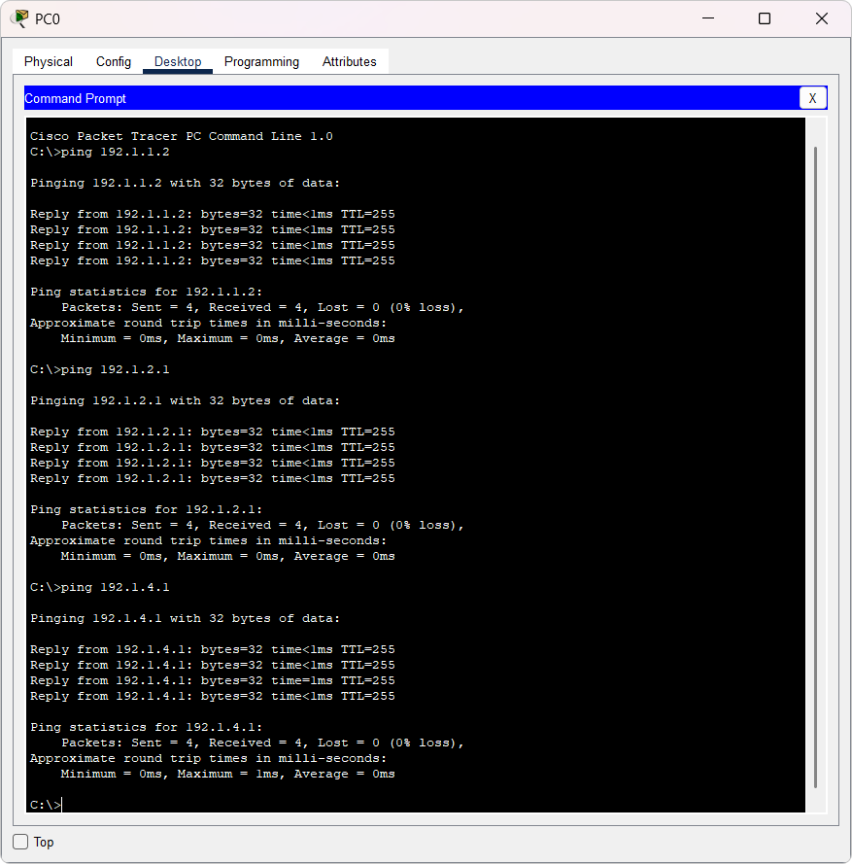

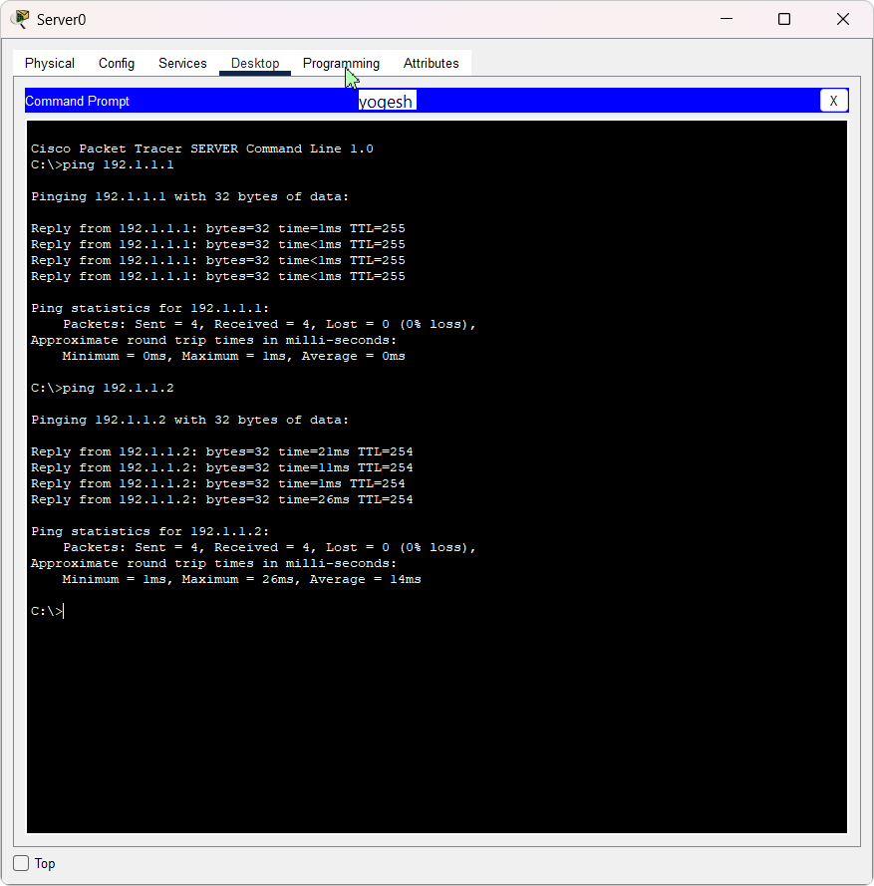

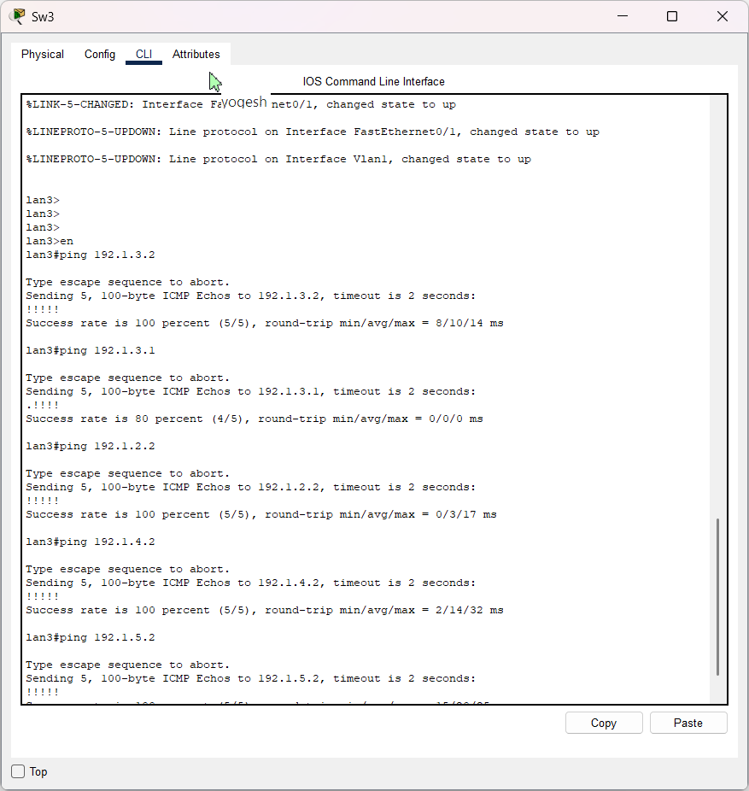

4. Implement and verify RIPv2 routing, show routing tables and IP route details.
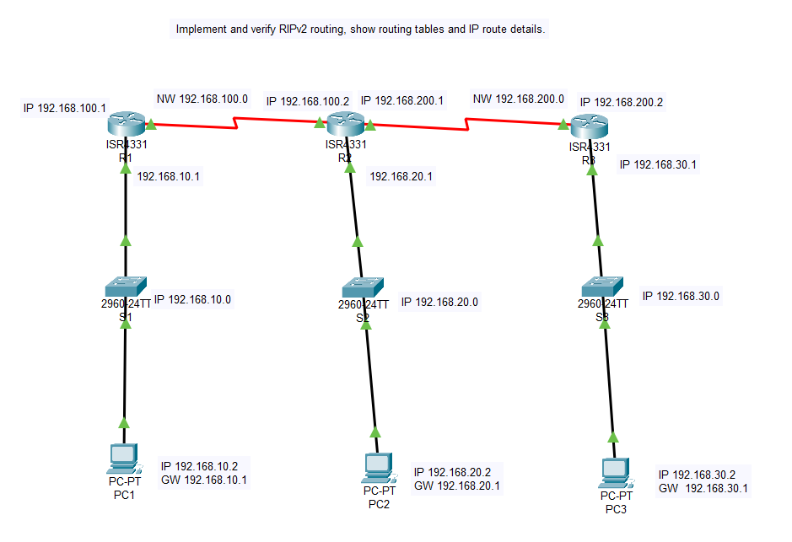

Router1:
Router>enable
Router#configure terminal
Router(config)#hostname R1
R1(config)#interface g0/0/0
R1(config-if)#ip address 192.168.10.1 255.255.255.0
R1(config-if)#no shutdown

R1(config-if)#interface s0/1/0
R1(config-if)#ip address 192.168.100.1 255.255.255.0
R1(config-if)#no shutdown

R1(config)#router rip
R1(config-router)#version 2
R1(config-router)#no auto-summary
R1(config-router)#network 192.168.10.0
R1(config-router)#network 192.168.100.0
R1(config-router)#exit
R1(config)#end
R1#write
-----------------------------------------------------------
Router 2
Router>enable
Router#configure terminal
Router(config)#hostname R2
R2(config)#interface g0/0/0
R2(config-if)#ip address 192.168.20.1 255.255.255.0
R2(config-if)#no shutdown

R2(config)#interface s0/1/0
R2(config-if)#ip address 192.168.100.2 255.255.255.0
R2(config-if)#no shutdown

R2(config)#interface s0/1/1
R2(config-if)#ip address 192.168.200.1 255.255.255.0
R2(config-if)#no shutdown

R2(config)#router rip
R2(config-router)#version 2
R2(config-router)#no auto-summary
R2(config-router)#network 192.168.20.0
R2(config-router)#network 192.168.100.0
R2(config-router)#network 192.168.200.0
R2(config-router)#exit
R2(config)#end
R2#write
Router 3
Router>enable
Router#configure terminal
Router(config)#hostname R3
R3(config)#interface g0/0/0
R3(config-if)#ip address 192.168.30.1 255.255.255.0
R3(config-if)#no shutdown

R3(config)#interface s0/1/0
R3(config-if)#ip address 192.168.200.2 255.255.255.0
R3(config-if)#no shutdown

R3(config)#router rip
R3(config-router)#version 2
R3(config-router)#no auto-summary
R3(config-router)#network 192.168.30.0
R3(config-router)#network 192.168.200.0
R3(config-router)#exit
R3(config)#end
R3#write
-----------------------------------------------------------
OUTPUT :
Run command from PC 192.168.10.2
Ping 192.168.30.2
tracert 192.168.30.2
Run command from PC 192.168.30.2
Ping 192.168.10.2
tracert 192.168.10.2
Run following commands in all Routers
1. show ip protocols
2. show ip route
3. show ip rip database
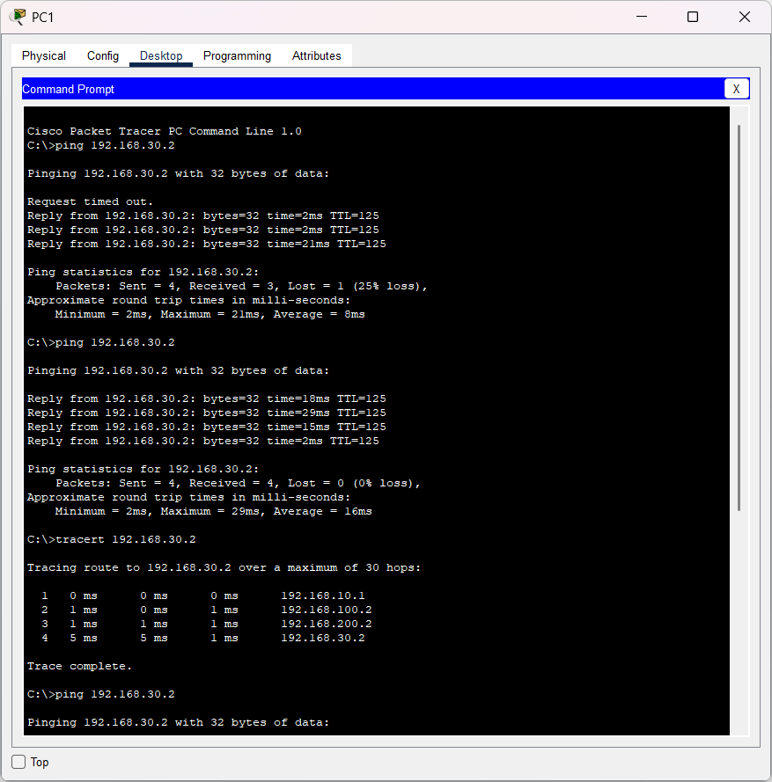
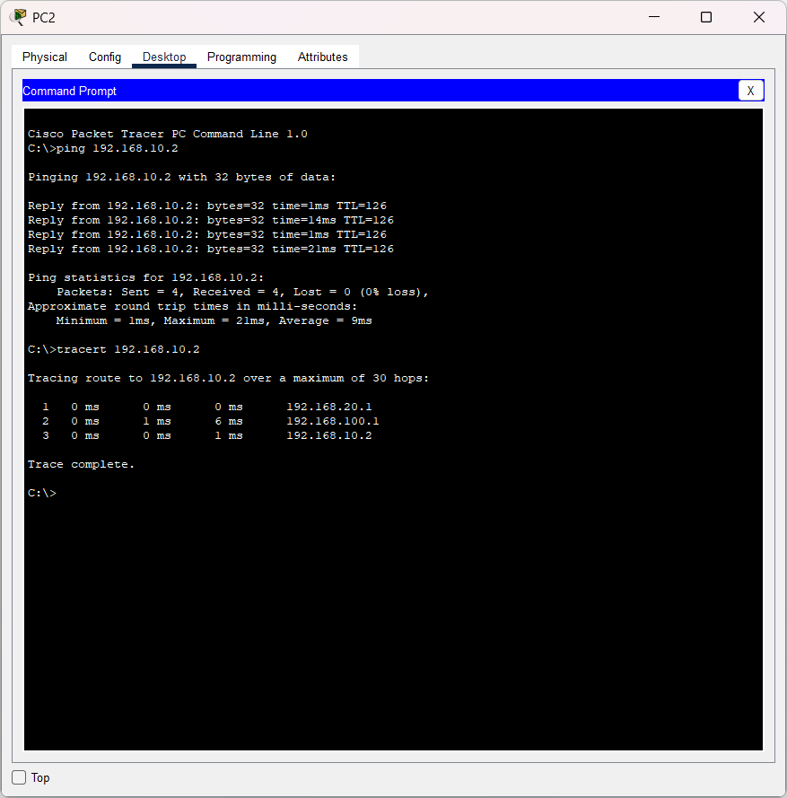

5. Configure EIGRP and show EIGRP neighbors and analyze EIGRP topology.

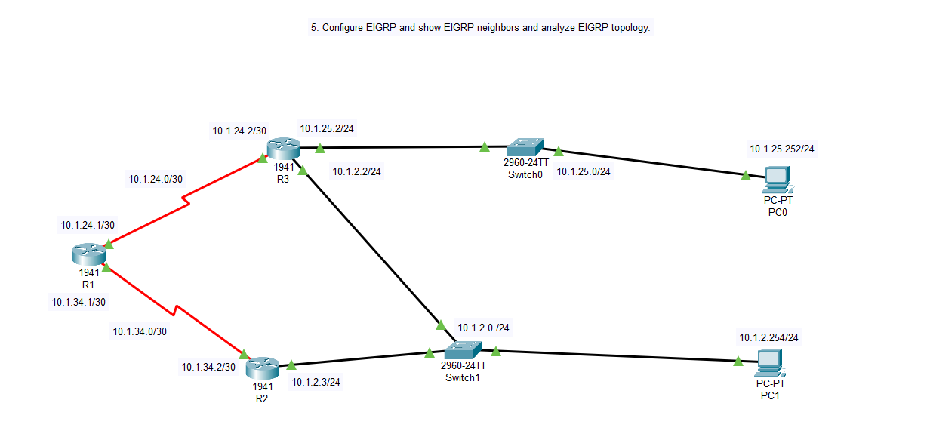

ROUTER 1
Router>enable
Router#configure terminal
Router(config)#hostname R1_1

R1_1(config)#interface s0/1/0
R1_1(config-if)#ip address 10.1.21.1 255.255.255.252
R1_1(config-if)#no shutdown
R1_1(config-if)#exit

R1_1(config)#interface s0/1/1
R1_1(config-if)#ip address 10.1.34.1 255.255.255.252
R1_1(config-if)#no shutdown
R1_1(config-if)#exit

R1_1(config)#router eigrp 50
R1_1(config-router)#no auto-summary
R1_1(config-router)#network 10.1.24.0 0.0.0.3
R1_1(config-router)#network 10.1.34.0 0.0.0.3
R1_1(config-router)#end
R1_1#write memory

ROUTER 2
Router>enable
Router#configure terminal
Router(config)#hostname R2_1

R2_1(config)#interface s0/1/0
R2_1(config-if)#ip address 10.1.34.2 255.255.255.252
R2_1(config-if)#no shutdown
R2_1(config-if)#exit

R2_1(config)#interface g0/0/0
R2_1(config-if)#ip address 10.1.2.3 255.255.255.0
R2_1(config-if)#no shutdown
R2_1(config-if)#exit

R2_1(config)#router eigrp 50
R2_1(config-router)#no auto-summary
R2_1(config-router)#network 10.1.34.0 0.0.0.3
R2_1(config-router)#network 10.1.2.0 0.0.0.255
R2_1(config-router)#end
R2_1#write memory

ROUTER 3

Router#configure terminal
Router(config)#hostname R3_1

R3_1(config)#interface s0/1/0
R3_1(config-if)#ip address 10.1.24.2 255.255.255.252
R3_1(config-if)#no shutdown
R3_1(config-if)#exit

R3_1(config)#interface g0/0/0
R3_1(config-if)#ip address 10.1.2.2 255.255.255.0
R3_1(config-if)#no shutdown
R3_1(config-if)#exit

R3_1(config)#interface g0/0/1
R3_1(config-if)#ip address 10.1.25.2 255.255.255.0
R3_1(config-if)#no shutdown
R3_1(config-if)#exit

R3_1(config)#router eigrp 50
R3_1(config-router)#no auto-summary
R3_1(config-router)#network 10.1.24.0 0.0.0.3
R3_1(config-router)#network 10.1.25.0 0.0.0.255
R3_1(config-router)#network 10.1.2.0 0.0.0.255
R3_1(config-router)#end
R3_1#write memory

pc0
IP Address: 10.1.25.254
Subnet Mask: 255.255.255.0
Default Gateway: 10.1.25.2
pc1
IP Address: 10.1.2.254
Subnet Mask: 255.255.255.0
Default Gateway: 10.1.2.3

Check following commands in all routers
R3_1#show ip route
R3_1#show ip eigrp neighbors
R3_1#show ip route eigrp
R3_1#show ip eigrp topology

OUTPUT
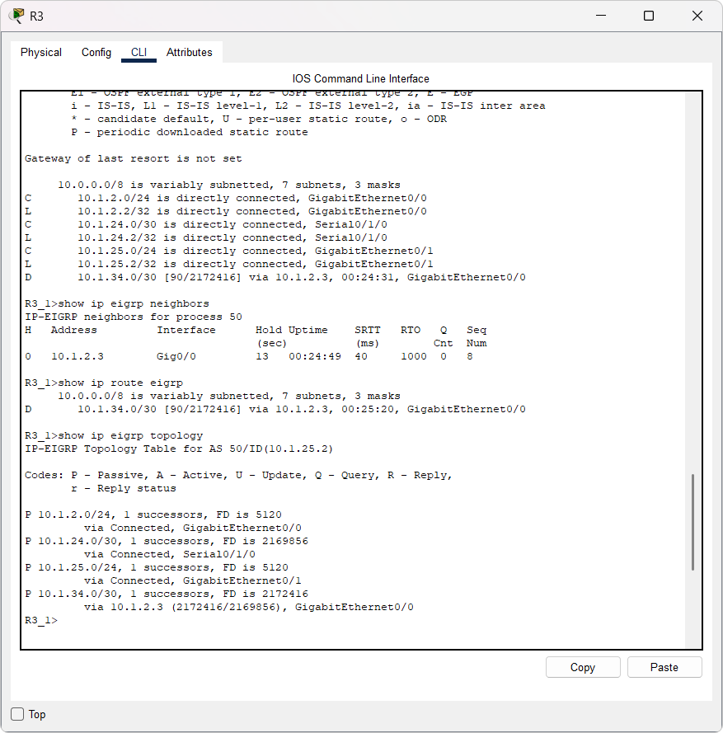

6. Build an OSPF based network using three interconnected routers.
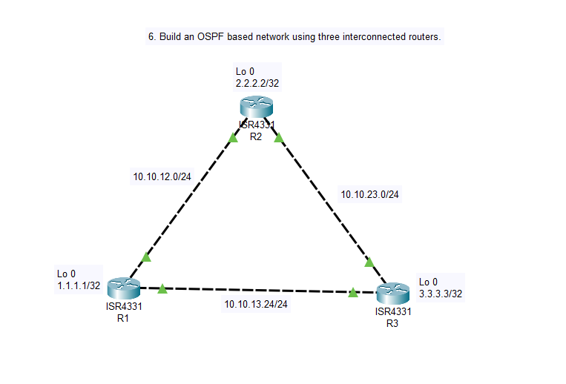
Router 1
Router>enable
Router#configure terminal
Router(config)#hostname R1_CSA66

R1_CSA66(config)#interface loopback 0
R1_CSA66(config-if)#ip address 1.1.1.1 255.255.255.255
R1_CSA66(config-if)#ip ospf 1 area 1
R1_CSA66(config-if)#no shutdownno
R1_CSA66(config-if)#exit

R1_CSA66(config)#interface g0/0/0
R1_CSA66(config-if)#ip address 10.10.12.1 255.255.255.0
R1_CSA66(config-if)#ip ospf 1 area 1
R1_CSA66(config-if)#no shutdown
R1_CSA66(config-if)#exit

R1_CSA66(config)#interface g0/0/1
R1_CSA66(config-if)#ip address 10.10.13.1 255.255.255.0
R1_CSA66(config-if)#ip ospf 1 area 1
R1_CSA66(config-if)#no shutdown
R1_CSA66(config-if)#exit

Router 2

Router>enable
Router#configure terminal
Router(config)#hostname R2_CSA66
R2_CSA66(config)#interface loopback 0
R2_CSA66(config-if)#ip address 2.2.2.2 255.255.255.255
R2_CSA66(config-if)#ip ospf 1 area 1
R2_CSA66(config-if)#no shutdown
R2_CSA66(config-if)#exit

R2_CSA66(config)#interface g0/0/0
R2_CSA66(config-if)#ip address 10.10.12.2 255.255.255.0
R2_CSA66(config-if)#ip ospf 1 area 1
R2_CSA66(config-if)#no shutdown
R2_CSA66(config-if)#exit

R2_CSA66(config)#interface g0/0/1
R2_CSA66(config-if)#ip address 10.10.23.2 255.255.255.0
R2_CSA66(config-if)#ip ospf 1 area 1
R2_CSA66(config-if)#no shutdown
R2_CSA66(config-if)#exit

Router 3

Router>enable
Router#configure terminal
Router(config)#hostname R3_CSA66

R3_CSA66(config)#interface loopback 0
R3_CSA66(config-if)#ip address 3.3.3.3 255.255.255.255
R3_CSA66(config-if)#ip ospf 1 area 1
R3_CSA66(config-if)#no shutdown
R3_CSA66(config-if)#exit

R3_CSA66(config)#interface g0/0/0
R3_CSA66(config-if)#ip address 10.10.23.3 255.255.255.0
R3_CSA66(config-if)#ip ospf 1 area 1
R3_CSA66(config-if)#no shutdown
R3_CSA66(config-if)#exit

R3_CSA66(config)#interface g0/0/1
R3_CSA66(config-if)#ip address 10.10.13.3 255.255.255.0
R3_CSA66(config-if)#ip ospf 1 area 1
R3_CSA66(config-if)#no shutdown
R3_CSA66(config-if)#exit

Final Test: Ping from Loopback to Loopback

From R1:
ping 2.2.2.2
ping 3.3.3.3
--------------------
From R2
ping 1.1.1.1
ping 3.3.3.3
---------------------
From R3:
ping 1.1.1.1
ping 2.2.2.2

All routers:
sh ip int br
show ip ospf neighbor
show ip route
show ip protocols
show ip ospf
show ip ospf interface
OUTPUT

